**ARCHETECTURE OF 8051 MICROCONTROLLER**

EVOLUTION OF MICROCONTROLLER **:**

First, microcontroller were developed in the mid-1970s. These were basically

calculator-based processors with small ROM program memories, very limited RAM data

memories and a handful of input/output ports.

As silicon technology developed, more powerful, 8-bit microcontrollers were

Produced. In addition to their improved instruction sets, these microcontrollers included

on-chip counters/timers, interrupt facilities, and improved I/O handling. On-chip memory

capacity was still small and was not adequate for many applications. One of the most

significant developments at this time was the availability of On-chip ultraviolet -

erasable EPROM memory. This simplified the product development time considerably and

for the first time, also allowed the use of microcontrollers in low-volume applications.

The 8051 family was introduced in the early 1980s by Intel. Since its introduction,

The 8051 has been one of the most popular microcontrollers and has been second - sourced

by the manufactures. The 8051 currently has many different versions and some types included on-chip analogue-to-digital converters, a considerable large size of program and data memories.

**INTRODUCTION TO 8051 MICROCONTROLLER :**

The **Intel MCS-51** ( commonly referred to as 8051 ) is a Harvard architecture, single chip

microcontroller (μ-C) series which was developed by Intel in 1980 for use in embedded

systems. The 8051 architecture provides many functions (CPU, RAM, ROM, I/O, Interrupt

Logic, timer, etc.) in a single package.

Features of 8051 microcontroller :

▪ **8-bit ALU, Accumulator, 8-bit Registers and 8-bit data bus; hence**

**it is an 8-bit microcontroller**

▪ **16-bit program counter**

▪ **8-bit Processor Status Word(PSW)**

▪ **8-bit Stack Pointer**

▪ **Internal RAM of128bytes On chip ROM is4KB**

▪ **Special Function Registers (SFRs) of 128bytes**

▪ **32 I/O pins arranged as four 8-bit ports (P0 -P3)**

▪ **Two 16-bit timer/counters : T0 andT1**

▪ **Two external and three internal vectored interrupts**

▪ **Full duplex UART (serial port)**

**BLOCK DIAGRAM :**

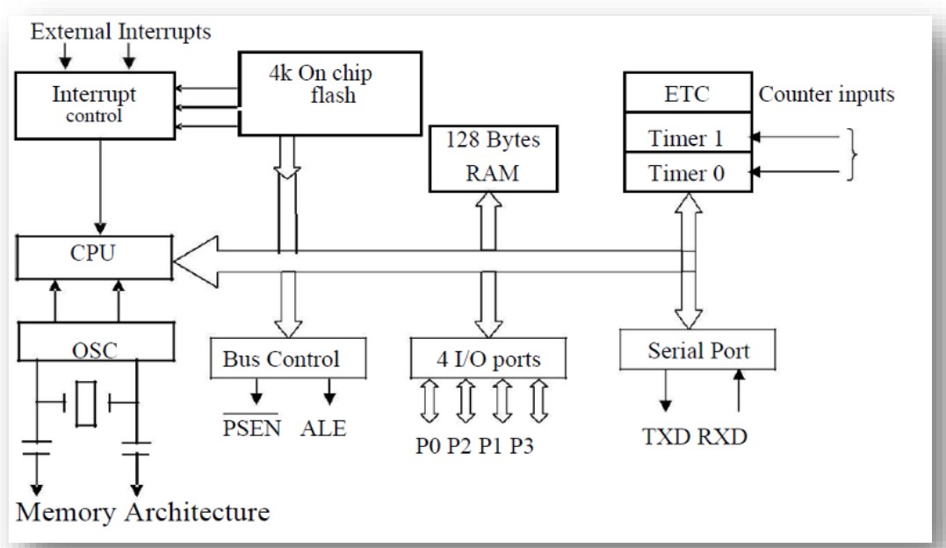

**MICROCONTROLLER BLOCK DIAGRAM**

**128 BYTES OF INTERNAL RAM STRUCTURE (LOWER ADDRESS SPACE)**

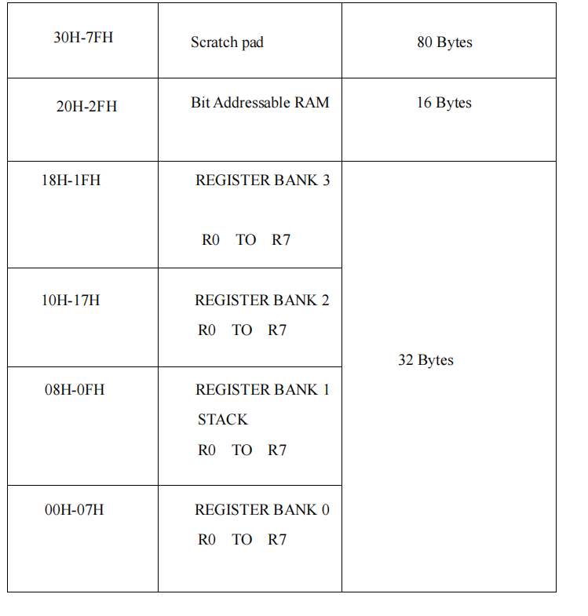

**RAM ALLOCATION IN 8051 MICROCONTROLLER**

The lower 32 bytes are divided into 4 separate banks. Each register bank has 8 registers of one byte each . A register bank is selected depending upon two bank select bit in the PSW register as shown in the above tabular .

▪ Next 16 bytes are bit addressable . In total,128 bits (16X8) are available in

addressable area . Each bit can be accessed and modified by suitable instructions.

The bit addresses are from 00H(LSB of the first byte in 20H)

to 2FH(MSB of the last byte in 2FH).

▪ Remaining 80 bytes of RAM (30H TO 7FH) are available for general purpose.

INTERNAL ARCHITECTURE OF 8051 MICROCONTROLLER :

**The internal architecture is shown in above tabular and the**

**various Registers and units are described below .**

ACCUMULATOR(ACC) :

▪ Operand register

▪ Implicit or specified in the instruction

▪ Has an address in on chip SFR bank

B REGISTER :

Used to store one of the operated for multiplication and division,

otherwise ,scratch pad considered as a SFR.

STACK POINTER (SP) :

8 bit wide register .incremented before data is stored on the stack using

PUSH or CALL instruction. Stack defined anywhere on the 128 byte RAM.

Data Pointer (DPTR) :

16 bit register contain DPH and DPL pointer to external RAM

address. DPH and DPL allotted separate addresses in SFR bank

Port 0 To 3 Latches & Drivers :

Each I/O port allotted a latch and a driver Latches allotted address in

SFR . User can communicate via these ports P0,P1,P2,andP3 .

Serial Data Buffer :

Internally had TWO independent register ,TRANSMIT buffer (parallel in

serial out -PISO) and RECEIVE buffer (serial in parallel out -SIPO) identified by SBUF and

allotted an address in SFR.

Program Status Word (PSW) :

Set of flags contains status information as detailed below in the tabular



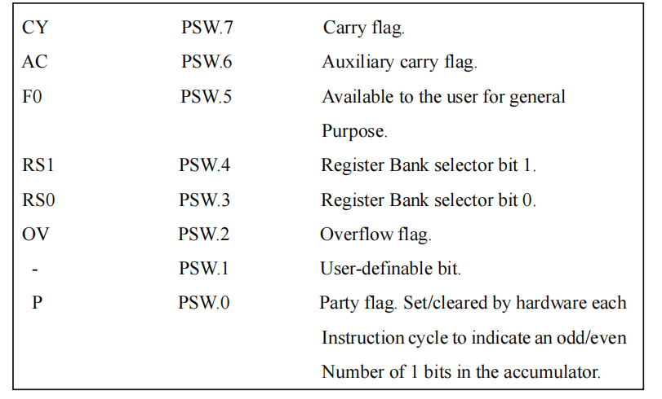

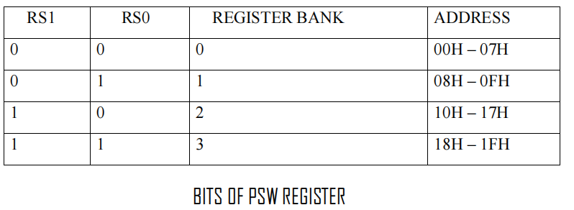

Timer Registers :

for Timer 0(16 bit register - TLO & THO) and for timer 1 (16 bit register- TL1

&TH1) Four addresses allotted in SFR.

Control Registers :

Control register are IP,IE,TMOD,TCON,SCON ,and PCON .These register

contain control and status information for interrupts ,timer /counters and serial port. Allowed

separated address in SFR .

Oscillator :

generation basic timing clock signal using crystal oscillator.

Instruction Register :

Decodes the opcode and gives information to timing and control unit .

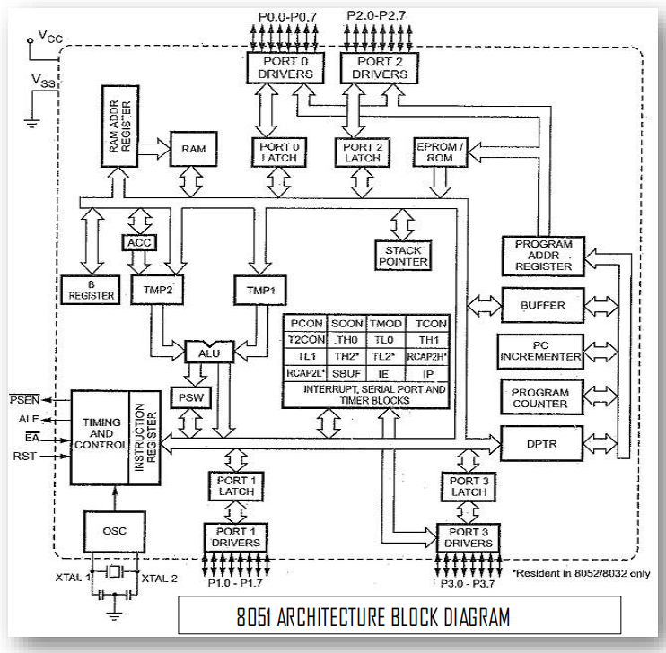

EPROM & PROGRAM ADDRESS REGISTER :

provide on chip EPROM and mechanism to address it . All version don’t

have EPROM.

RAM & RAM ADDRESS REGISTER :

provide internal 128 bytes RAM and a mechanism to address internally .

ALU :

perform 8 bit arithmetic and logical operation over the operands held by TEMP1

TEMP 2. User cannot access temporary registers.

SFR REGISTER BANK :

set of special function registers address range: 80H to FF H.

Interrupt ,serial port and timer units control and perform specific function under the control

of timing and control unit .

8051 PIN CONFIGURATION

The pin diagram of 8051 microcontroller is shown in the below figure and the pin

details are described below .

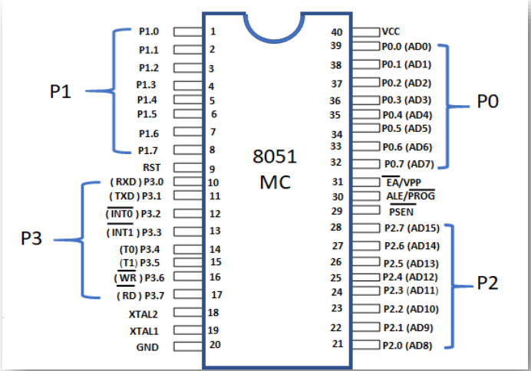

PINS 1 TO 8 :

These pins are known as port 1. This port doesn’t serve any other functions .It

is internally pulled up ,bi-direction I/O port.

PIN 9 :

It is a RESET pin ,which is used to reset the microcontroller to its initial values .

PINS 10 TO 17 :

These pins are known as port 3. This port serve some alternate functions like

interrupts , timer input ,control signals, serial communication signals Rx D and Tx D etc.

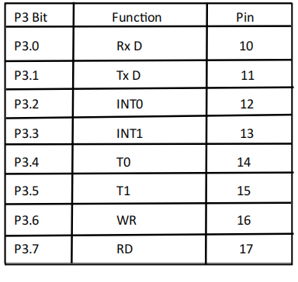

PORT 3 ALTERNATE FUNCTIONS

PINS 18 & 19 :

These pins are used for interfacing an external crystal to get system clock.

PIN 20 :

These pin the power supply to the circuit .

PIN 21 to 28 :

These pins are known as port2 . It serves as I/O port. Higher order address bus signals are also multiplexing using this port .

PIN 29 :

This is PSEN pin which stands for program store Enable . It is used to read a signal from the

external program memory.

PIN 30 :

This is EA pin which stands for External Access input . it is used to enable/disable the external

memory interfacing.

PIN 31 :

This is ALE pin which stands for address latch Enable . It is used to demultiplex the address –

data signal of port.

PINS 32 TO 39 :

These pins are known as port 0.It serves as I/O port .Lower order address and data bus signals are multiplexed using this port.

PIN 40 :

This pin is used to provide power supply to the circuit.

*PREPARED BY:* **ADITYA KUMAR**